|  |  |
| --- | --- |
| **Project – External Documentation** |  |
| COMP6051016  Web Programming |
| Even Semester Year 2022/2023 |

* Project Title

Jramedia

* Introduction

This project is intended for our class project named Web Programming class in Binus University. The main goal of this project to create website by Laravel framework. Our project name is JRamedia, this is a website of selling book or stationery with the form like e-commerce.

* Report / Documentation

1. Login Page

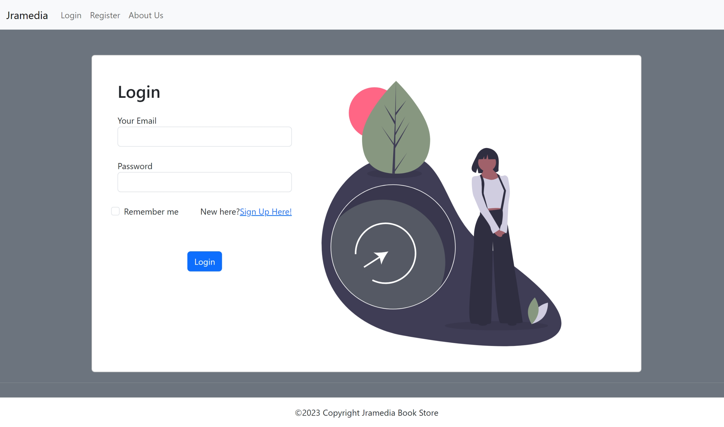

This login page is intended to authorize user. Basically, this page is use for authenticating the user and will be directed the user to the page with their dedicated role (admin/customer). If the user’s role is admin, then after login, the user will be directed to admin home page. If the user’s role is customer, then the user will be directed to customer homepage. The remember me feature is useful for saving the session and cookie user, so if the user has login, then user no need to login again as long as the cookie or session has not invalided by the time limit. Also, if the user is new to Jramedia, user can click to “Sign Up Here” to register account. So, this feature is useful for authenticating the registered user which want to use this website feature to either maintain or buying some product in Jramedia. The authentication consists of checking the credential user in the database, if the email is not exists then error message will be appeared, also if the email exists then need to check the inputted password must be same as the value in the database.

1. Register Page

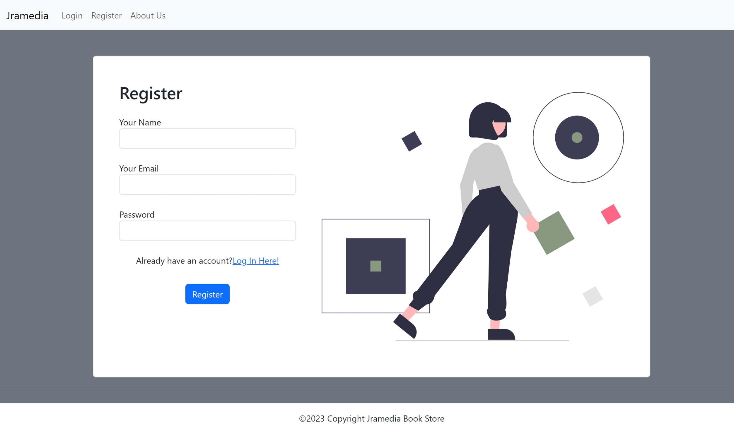

This register page is intended for new user which does not have an account in Jramedia, so basically this feature is use for new user to register new account in Jramedia. In this feature, the user will fill the name, email, and password to register their account. The validation in this field also been applicated, which consist of length of the name, validity of email, and length and terms which applied in password field. If the validation passed, then the user’s account has been registered to our system, else, the error message will be appeared. Also, there is validation where the email has been registered in our system, therefore the user cannot create with the same email. In this page, there is “Log in Here” which can be used by the user when they already have account which has been registered in our system. If user successfully registered, then user will be directed to login page again.

1. Home Page

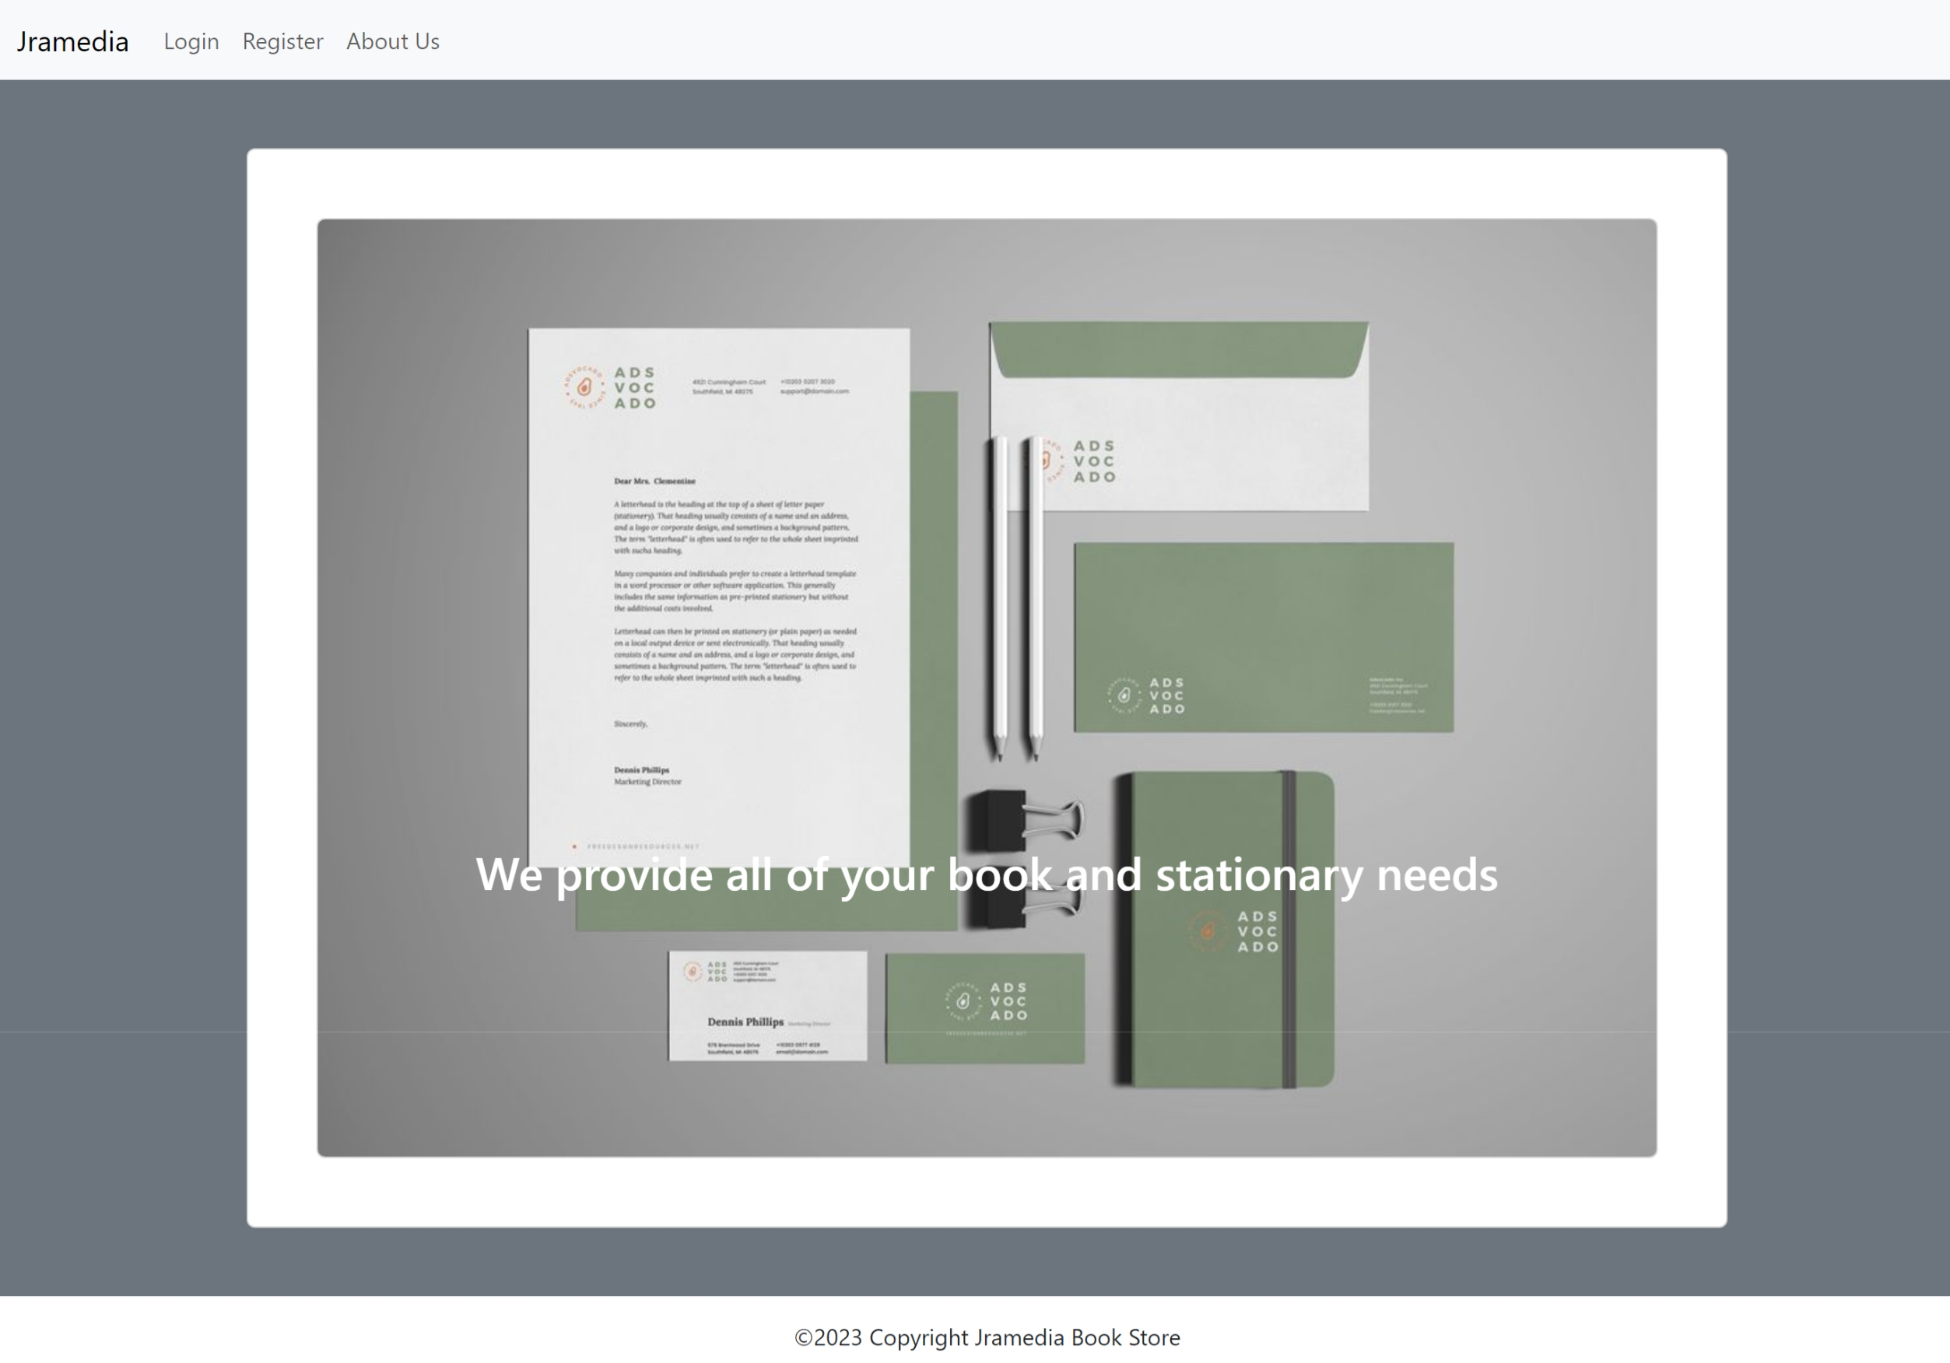

This home page will be appended to the user for the first time that user access our web application. In this page, we have navbar section which useful for user to select their preference option. In this page, we provided our slogan as book and stationary provider.

1. Admin Home Page

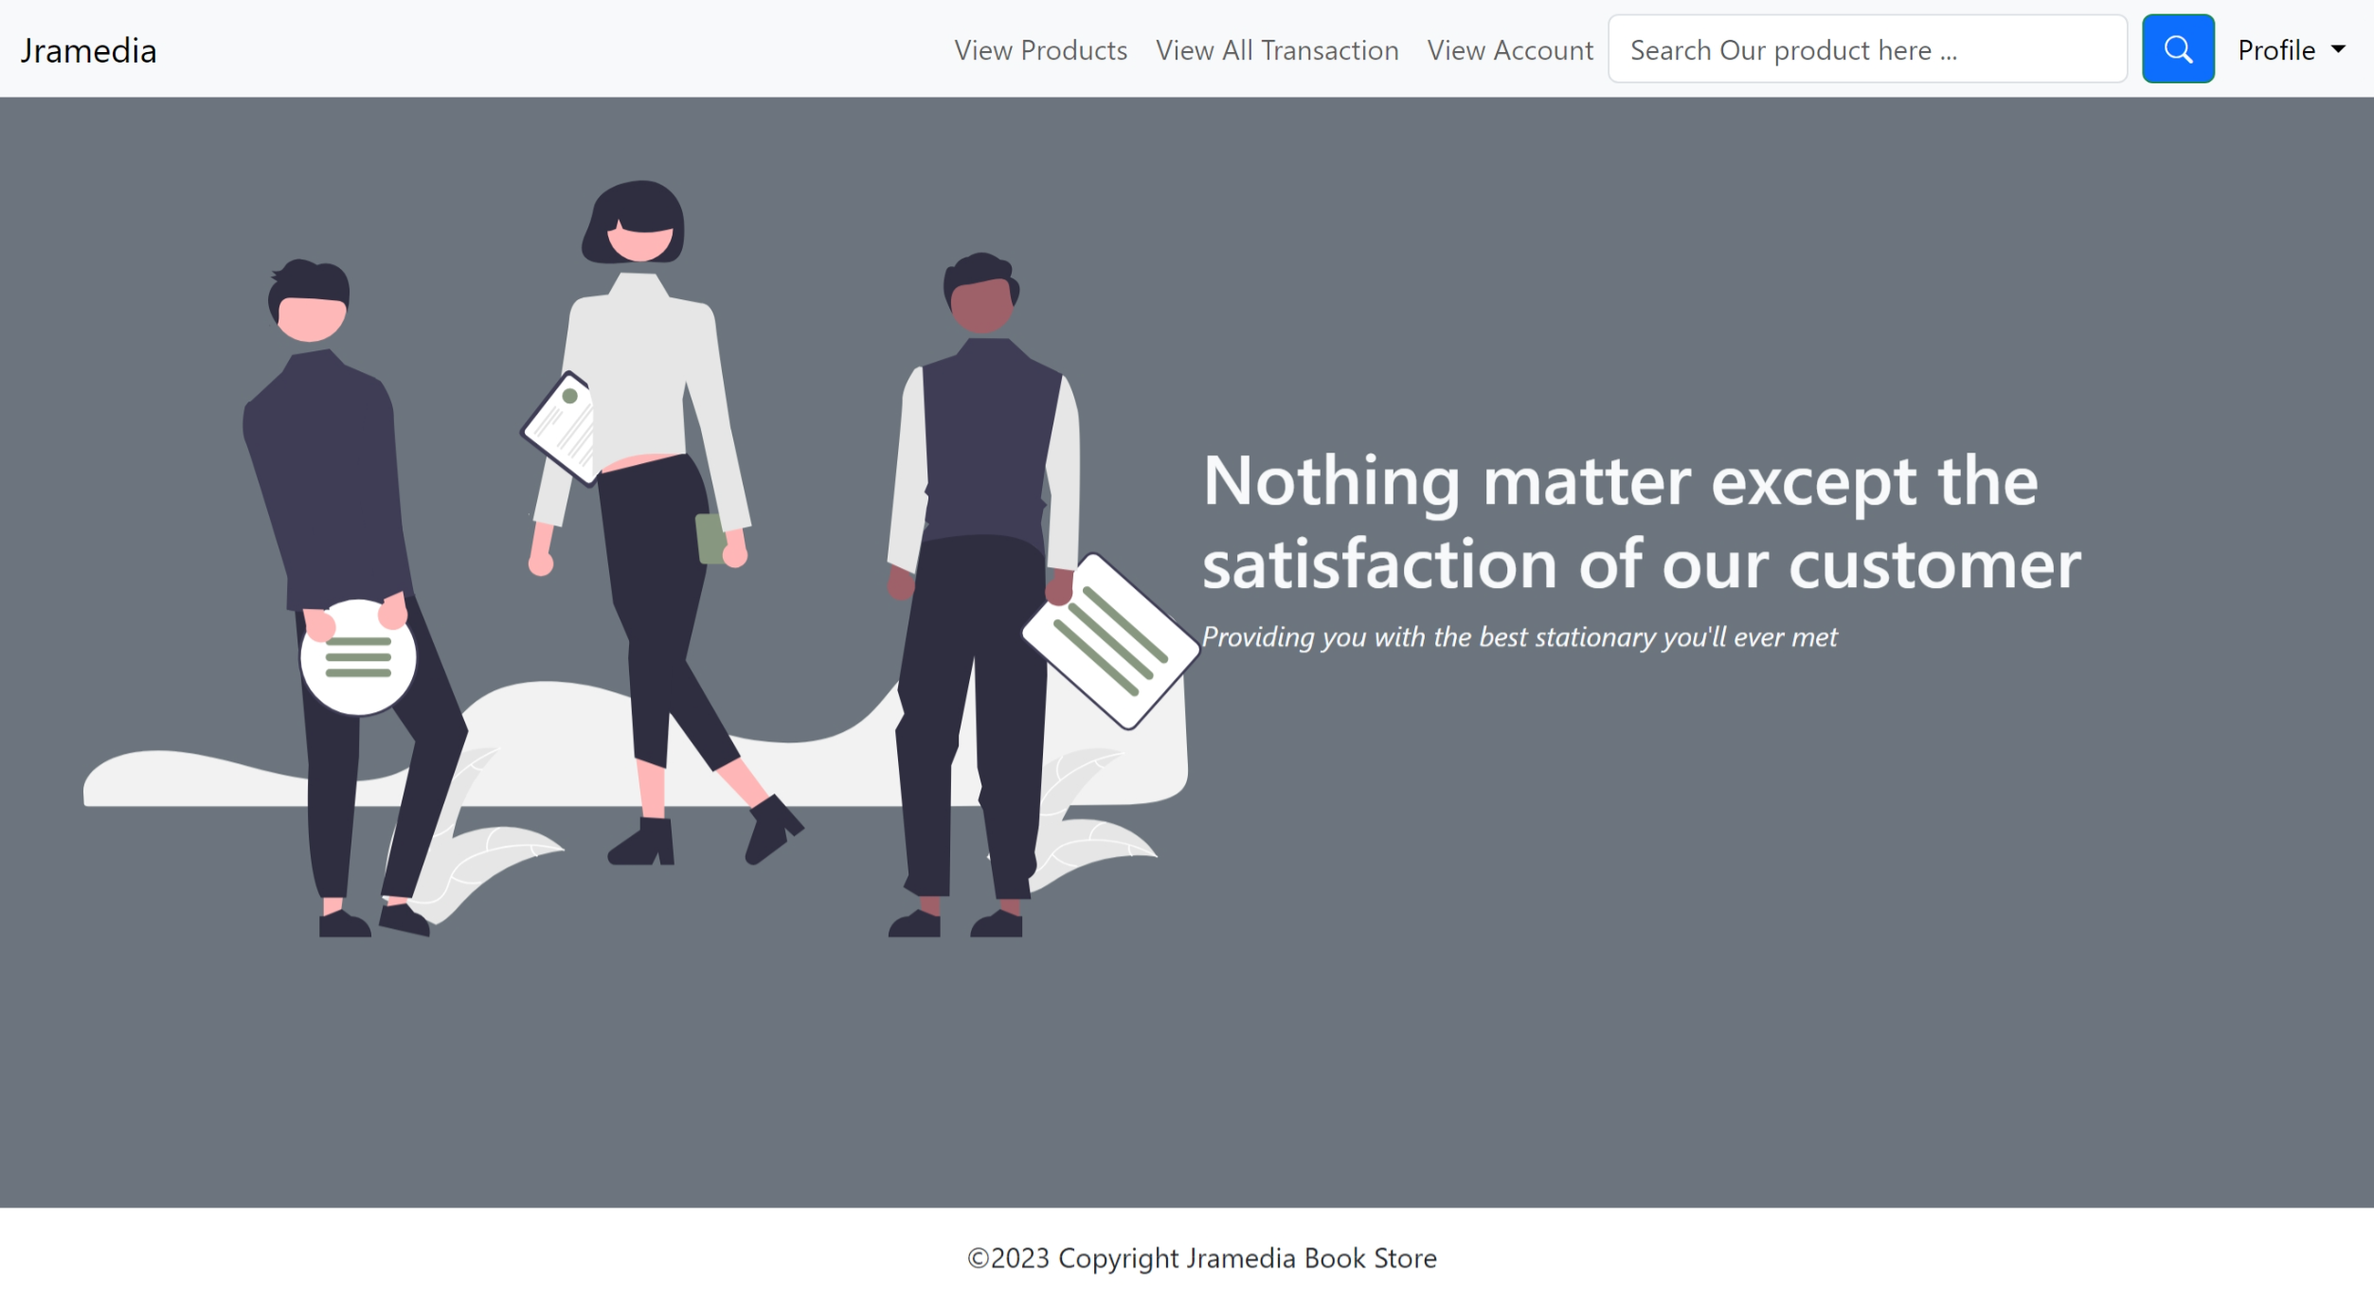

This admin home page will be appeared when the logged user has role as admin. In this page, we provided button of our feature for admin such as view products, view all transaction, view account, search bar, and profile dropdown. In this page, we provided our quotes as book and stationary provider.

1. Customer Home Page

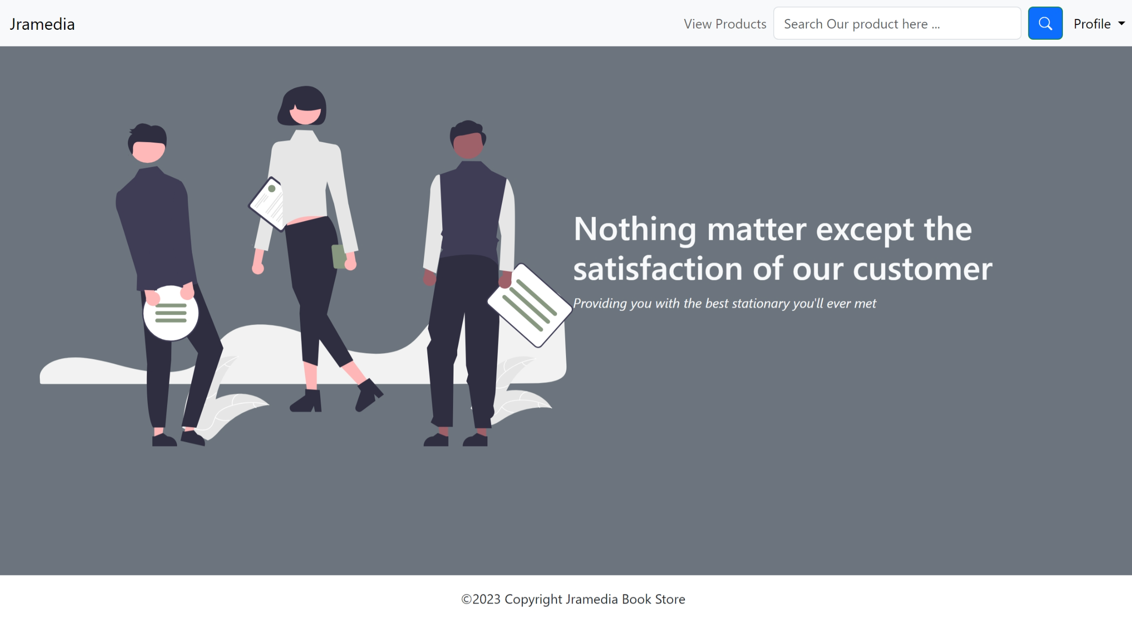

This customer home page will be appeared when the logged user has role as customer. In this page, we provided button of out feature for customer such as view products, search bar and profile which consists of my cart and log out.

1. Admin View Product Page

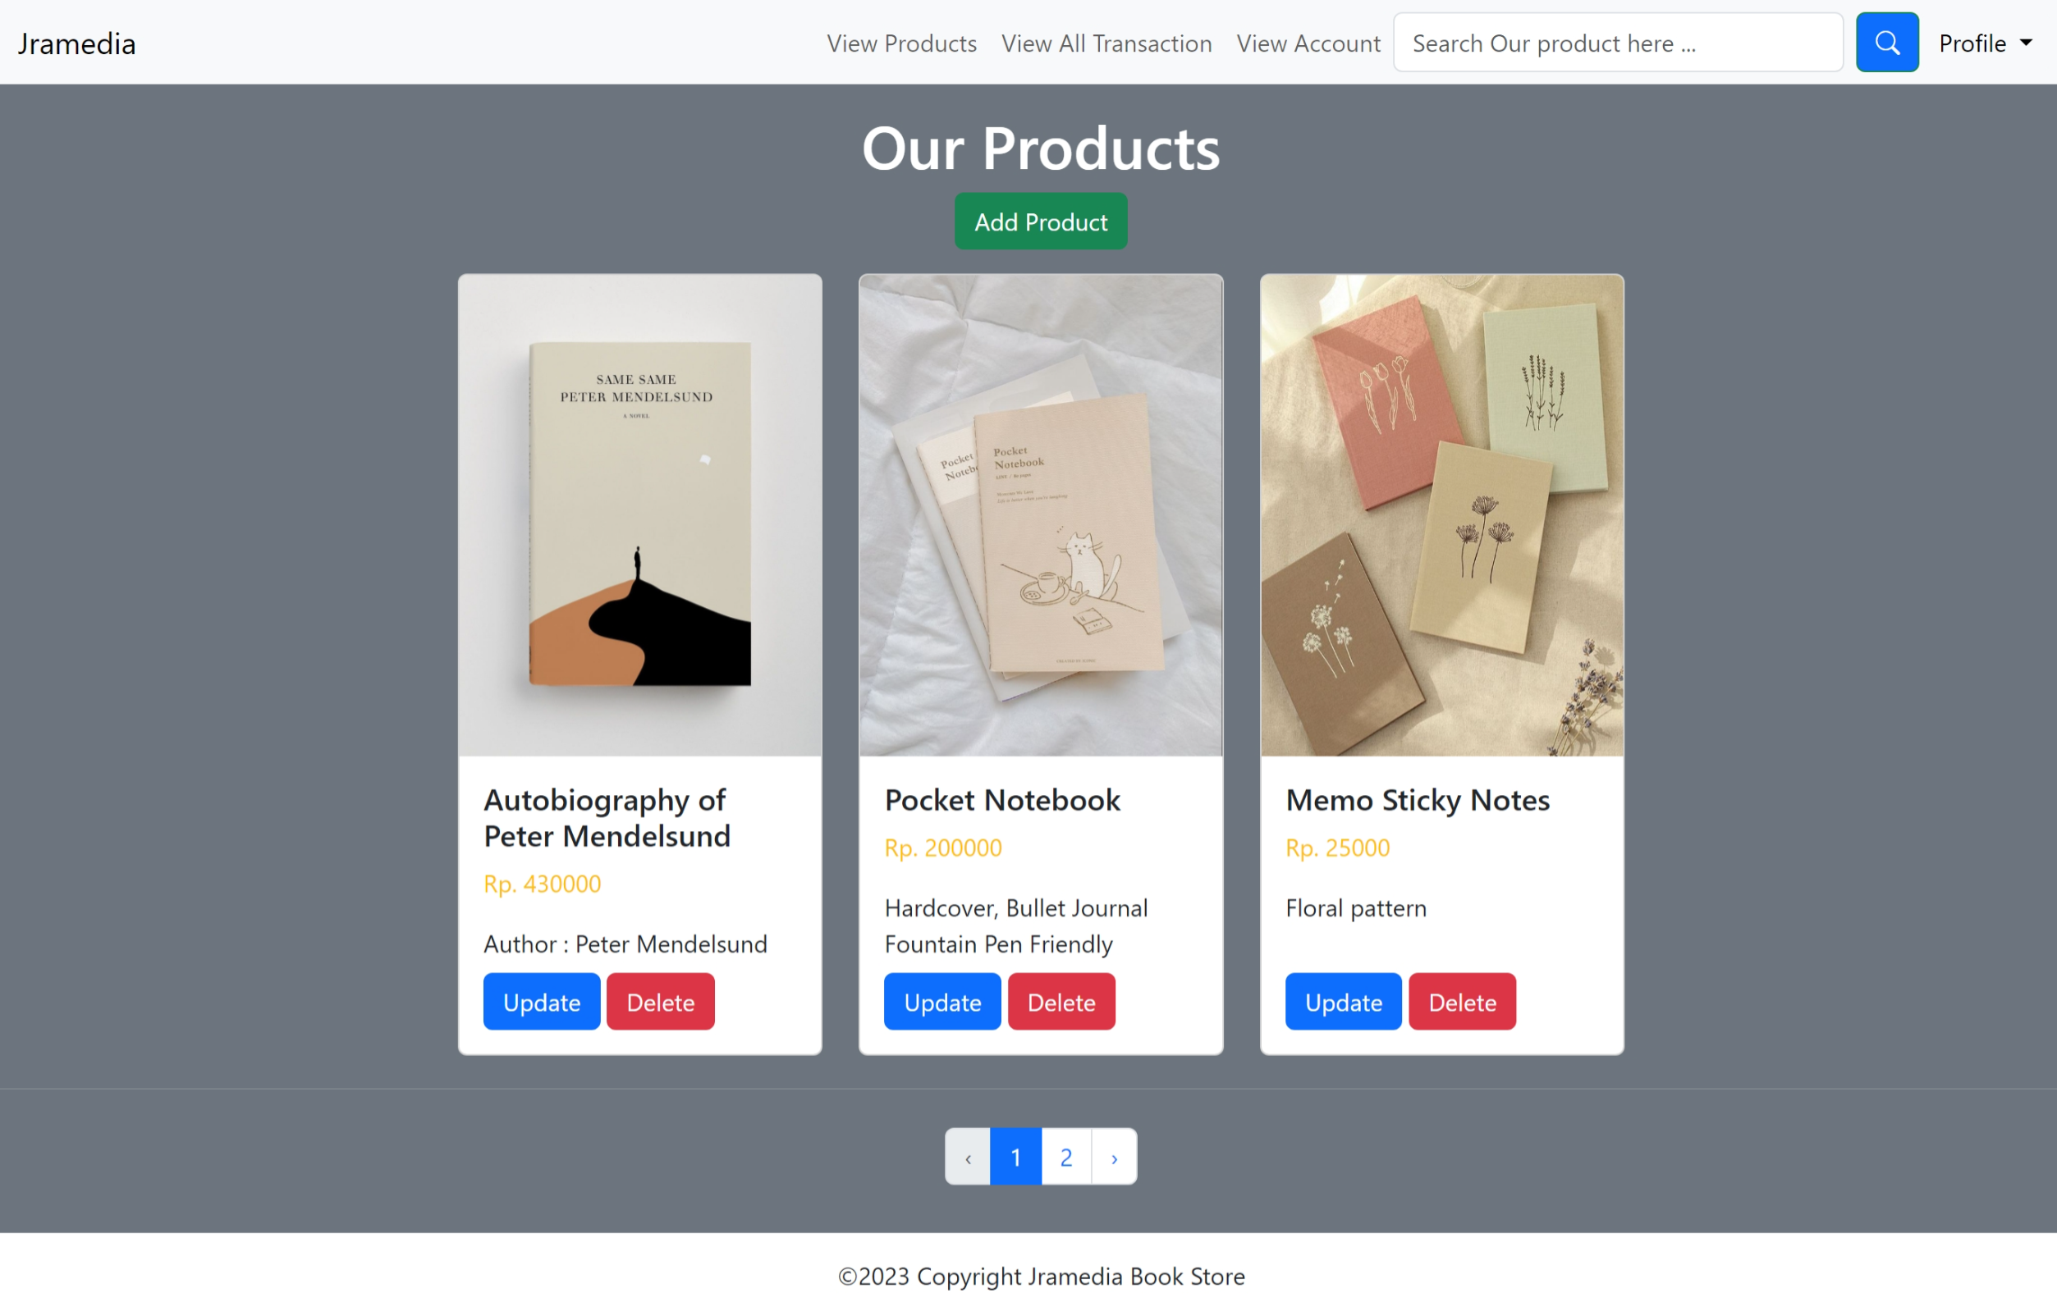

This admin view product page will be appeared when the admin selecting of our feature for viewing products. This page shows list of our products and the maintenance feature (Create, update, and delete product). Each page will be consisting of 3 products, in this case we use the pagination feature to support this.

1. Admin Add Product Page

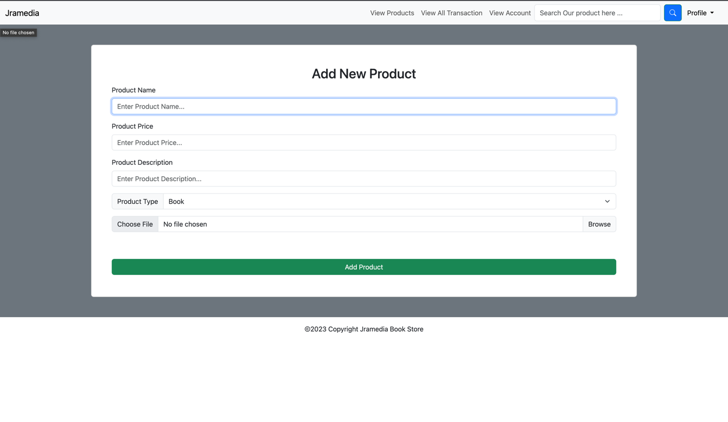

This admin add product page will be appeared when the admin triggered button for add product. There is validation to these fields, such as not empty, character length and many others. So, the admin will fill the field, and when the validation passes, then the product will be created.

1. Admin Update Product Page

This admin update product page will be appeared when the admin triggered button for edit product. There is validation to these fields, such as not empty, character length and many others. So, the admin will fill the field, and when the validation passes, then the product will be edited. This feature is similar like the add product, but the difference is on the functionality (edit).

1. Admin Delete Product Page

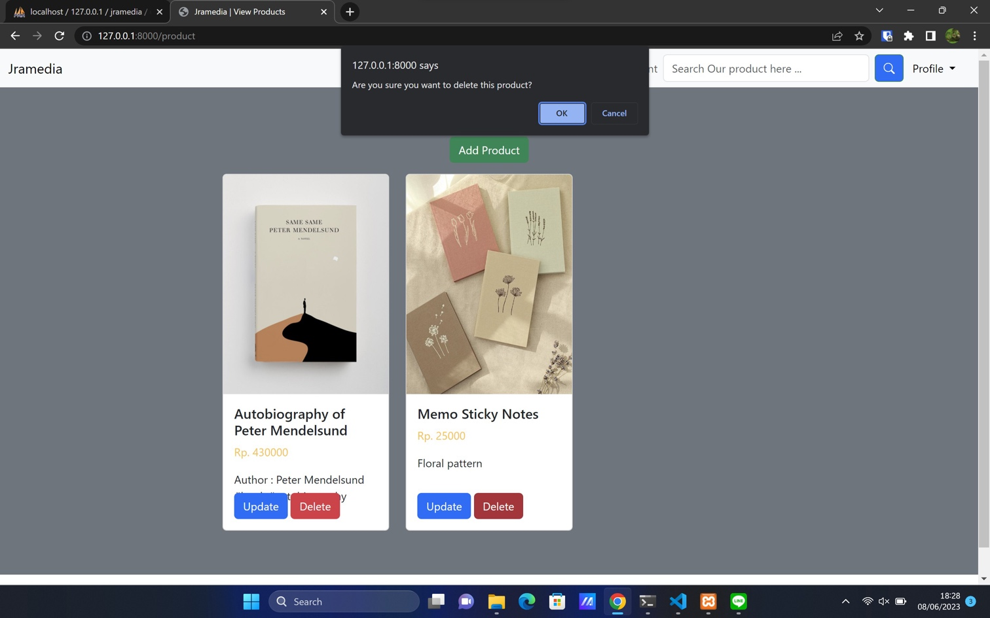

This admin delete product page will be appeared when the admin triggered button for delete product. There is validation to this action, if OK button is triggered, then the product will be deleted in our system. Else, the product will be cancelled to be cancelled.

This alert will be appeared when the product has successfully been deleted in our system.

1. Customer View Product Page

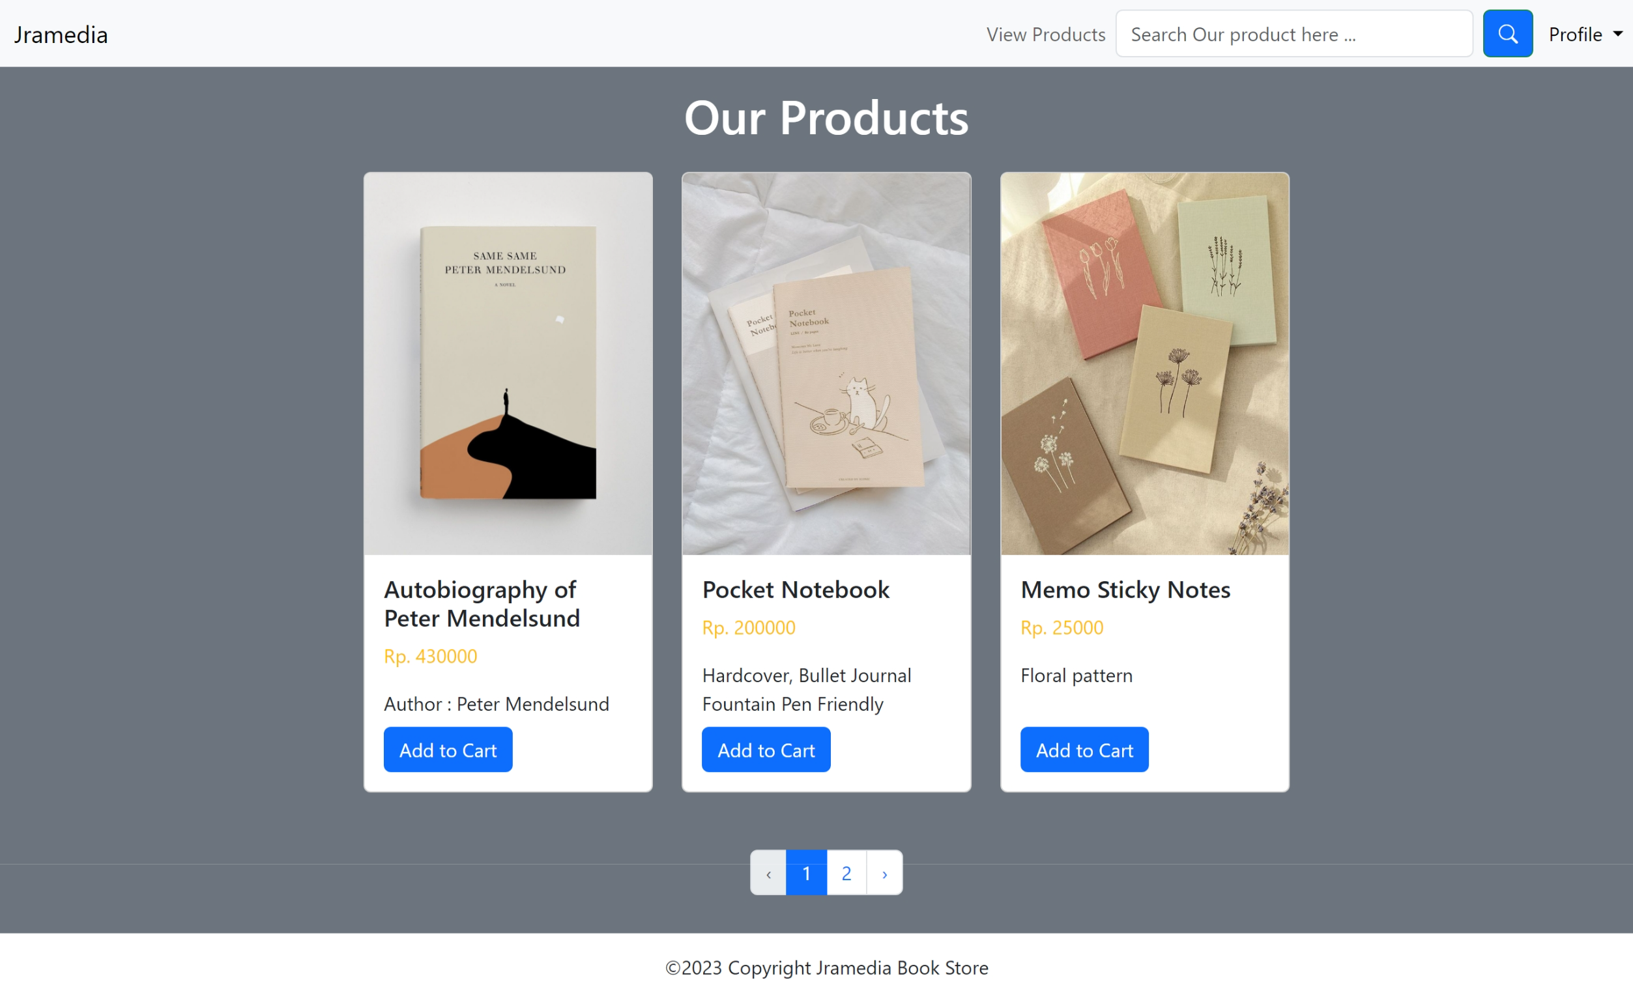

This customer view product page will be appeared when the customer selecting of our feature for viewing products. This page shows list of our products and add to cart feature. Each page will be consisting of 3 products, in this case we use the pagination feature to support this.

This page will be appeared when the customer adds to cart of product.

1. Search Product Page

The search product page will be appeared when the user/admin search keyword in search bar in navbar, then the result will be show as below:

This page will be appeared when the role is customer.

This page will be appeared when the role is admin.

1. Customer My Cart Page

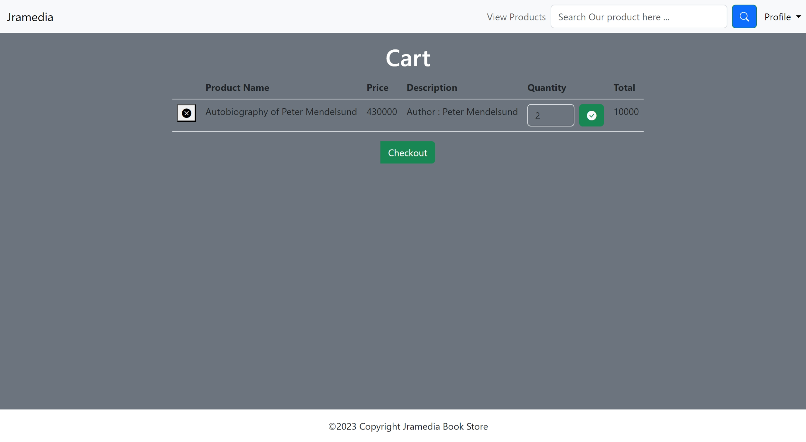

This customer my cart page will be appeared when the user trigger dropdown menu profile in navbar and click my cart. This page has a feature to see the products which has been added by customer in product page. In cart, user can update the quantity of the product and our system will be re-calculating the total after the user has triggered the checklist button on quantity. The quantity also has a validation that the number cannot be zero or below and the input must be number. Also, there is checkout button to check out the product in the cart, meaning that the customer has bought the product in the cart. Also, there is important things that user should do if they have updated the quantity, the checklist button must be triggered if there is change in quantity, therefore it will be saved in our system. If user not triggering that, the value will be same as before. So, after user has been checked out the items, then the detail of transaction will be inserted to our system for generating list of transaction which can be seen by admin.

1. Admin View All Transaction Page

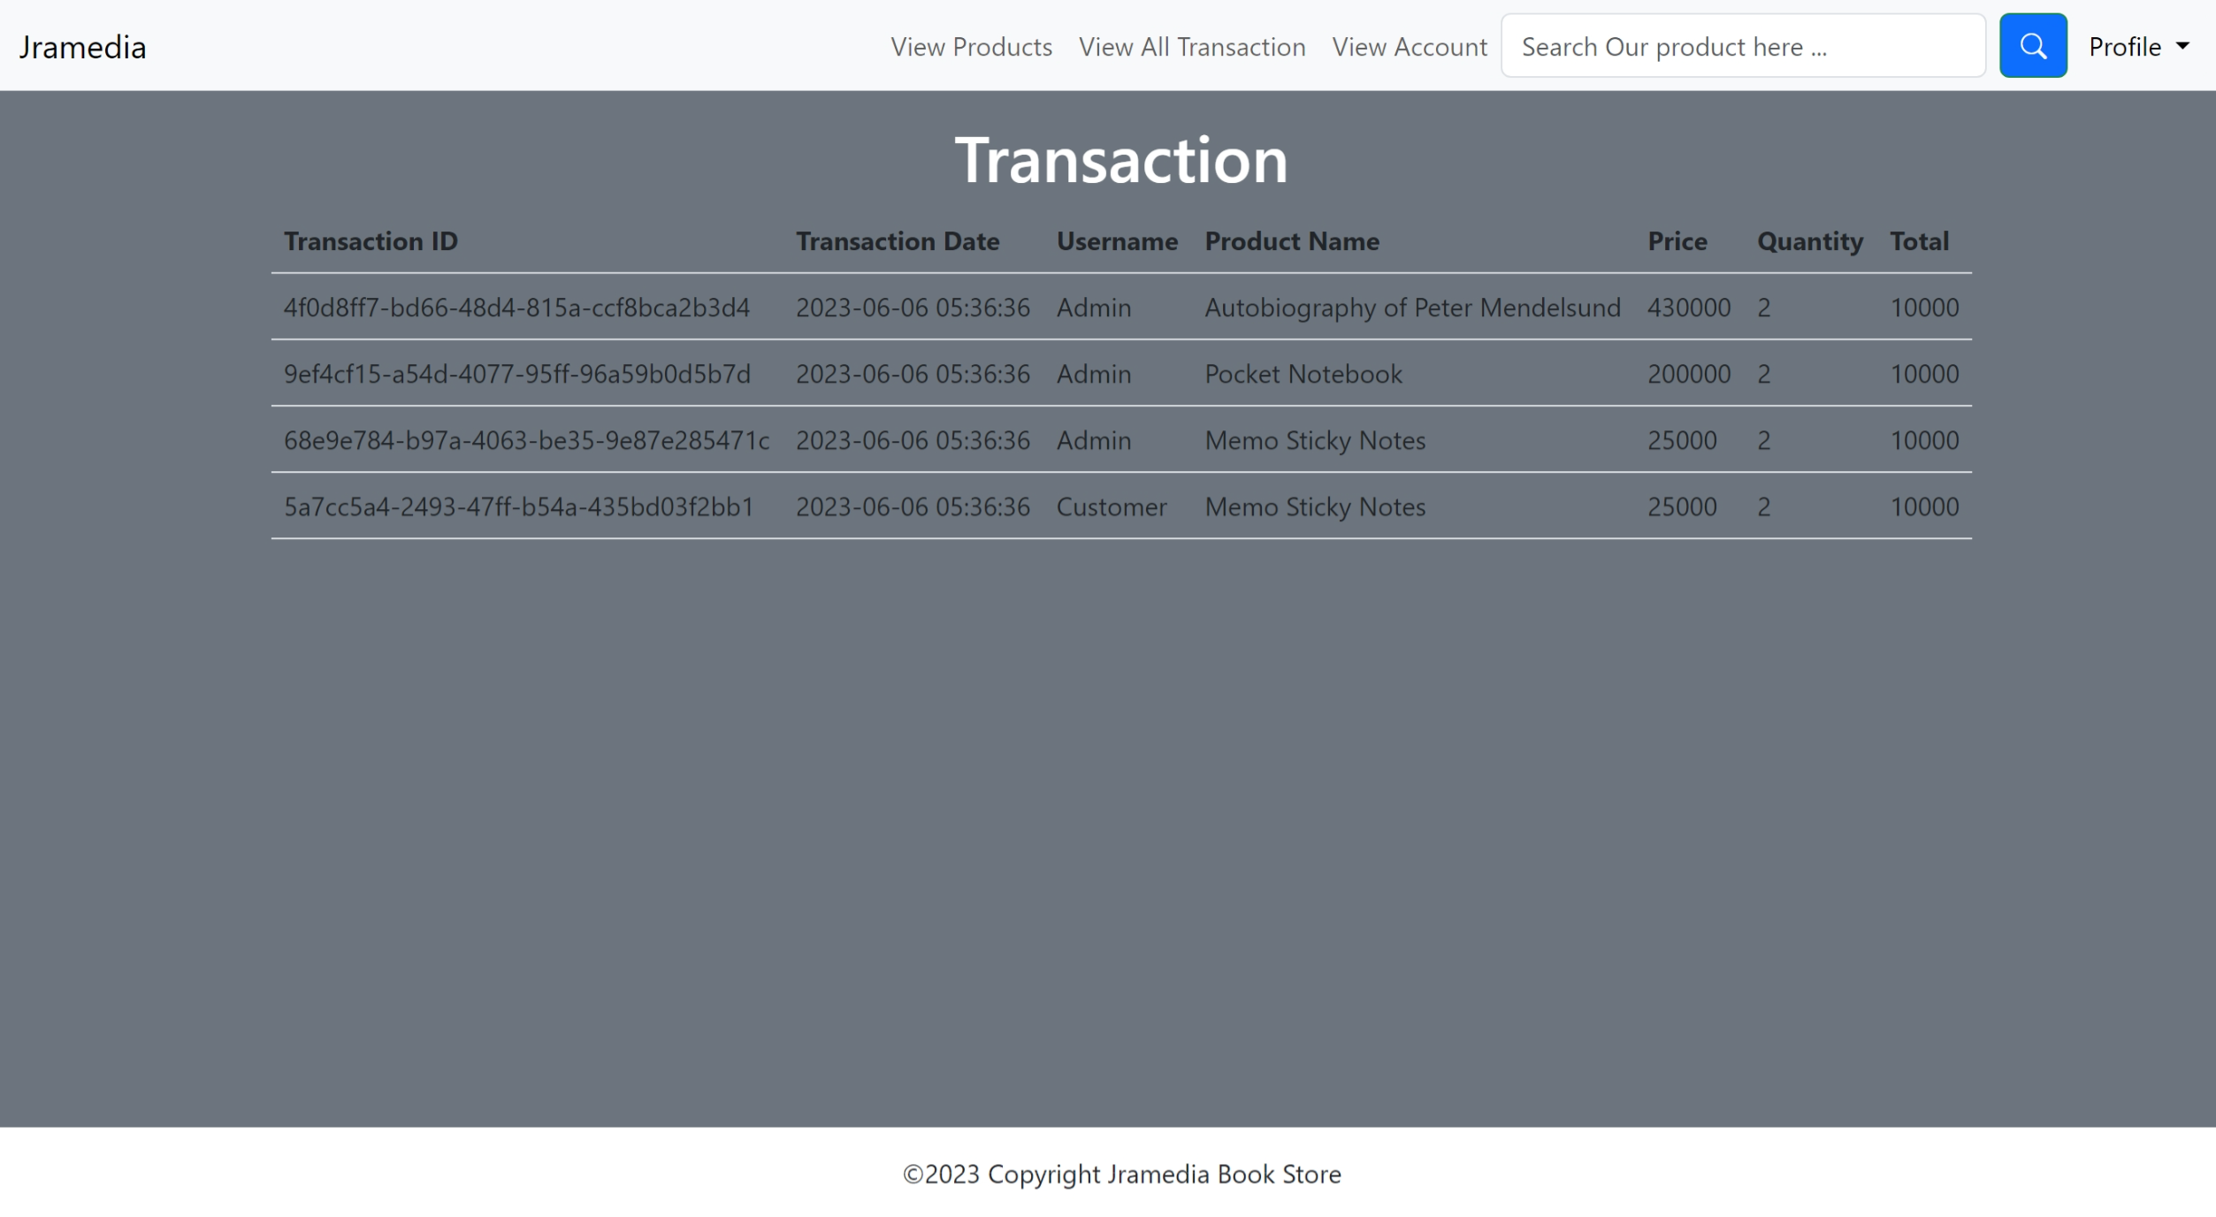

This admin view all transaction page will be appeared when the admin triggered the view all transaction option in our navbar section. In this feature, the admin can see the recorded activity of transaction, meaning that the transaction of user (checked out product). This page provides transaction id, transaction date, username, product name, price, quantity, and total. The notes of this page, the initial transaction is initiated and intended to testing purpose, so the total maybe not match with the calculation because it seeded by seeders which manually set by developers.

1. Admin View Account Page

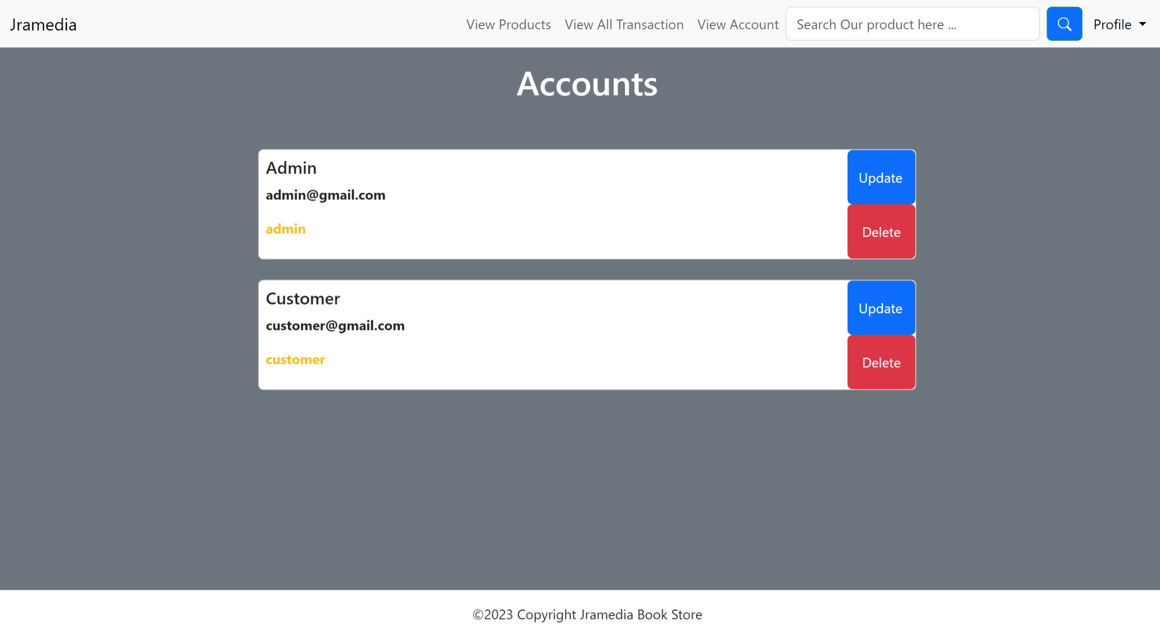

This admin view account page will be appeared when the admin triggered the view account page option in our navbar section. In this feature, admin can manage the registered account in our system such as update and delete account.

1. Admin Update Account Page

This admin update account page will be appeared when the admin triggered the update button in the view account page. In this feature, admin can update username, email, password, and role selected account in our system.

1. Admin Delete Account Page

This admin delete account page will be appeared when the admin triggered button for delete account. There is validation to this action, if OK button is triggered, then the account will be deleted in our system. Else, the account will be cancelled to be cancelled.

This alert will be appeared when the account has successfully been deleted in our system.

1. About Us

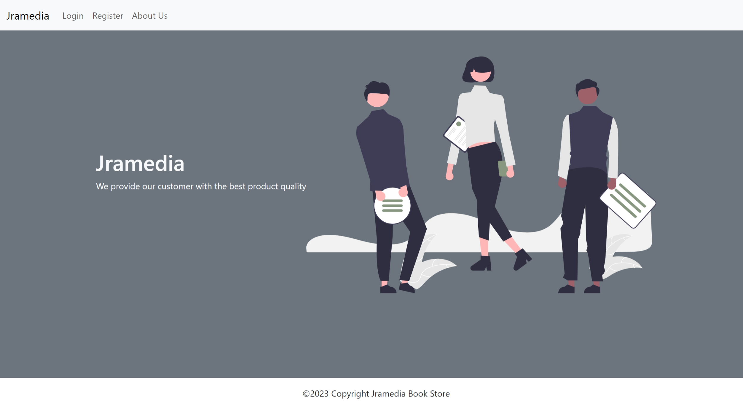

This about us page will be appeared when the user triggered the about us section in our navbar, and this page consists of our store name and our slogan.

* Reference
* https://www.behance.net/gallery/65552711/Stationery-Branding-Mock-Up
* https://www.petermendelsund.com/
* https://pin.it/453GOdm
* https://pin.it/IbdNqVV
* https://pin.it/4BTt6F6
* https://pin.it/7wV9kWZ
* https://undraw.co/
* Group Member
* 2301911842– Alyssa Imani
* 2301863023 – Karel Tan